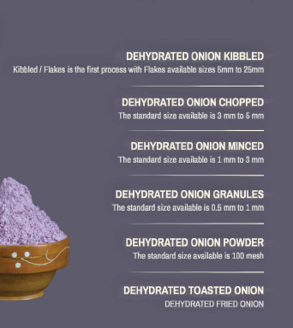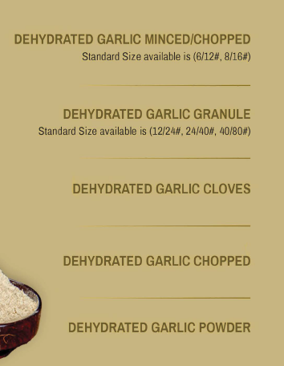

Onion and garlic dehydrated products offer convenient flavour enhancements to dishes. These pantry staples, derived from dried onions and garlic, provide a concentrated taste and aroma. Widely used in diverse cuisines, they are valued for their versatility and long shelf life. Incorporate these dehydrated ingredients to effortlessly elevate the savoury profile of your culinary creations.